Safety Recommendations
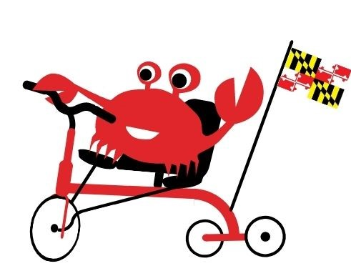
In order to ensure the safety of your child with their Amtryke bike, please adhere to the following safety recommendations:
- A properly fitted bike helmet and other protective gear should be wore at all times
- Adult supervision is required when riding your Amtryke Bike
- Before riding check your equipment (tire pressure, brakes, & steering)
- Stay alert at all times
- Avoid riding at night
- Watch for and avoid road/sidewalk hazards

